University Day 1

Canvas website:

* Main area is ‘Units’

Assignment next week

* Help with citations and research in context of software engineering speakers.

# Inside Canvas

Module Guide:

**Read the module guide:**

* Structure of the lesson’s week by week

**Unit instructions:**

What you will cover that day

**Review:**

Review contains the videos

**Portfolio Tasks**

Check your understanding what you’ve covered this week and understand it

* Set on Friday, and uploaded by the following Thursday

**Repl.it**

Repl.it is a way of being able to run code in the browser, within Canvas the code may already be there completed ready to view.

# Once code is submitted to GIT, it will be reviewed by Gavin and feedback/grade will be given. It will take 4 weeks for the document/items to be marked.

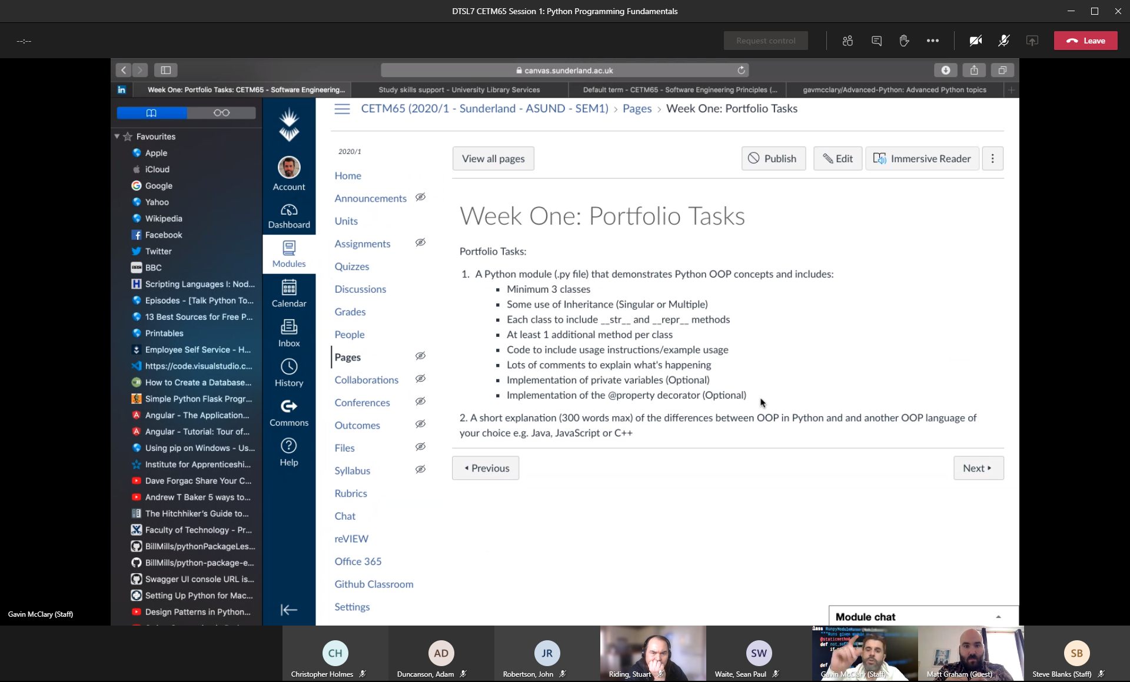

Book classes

Employee classes

* Add an employee
* Search for an employee
* Address of an employee
* scheduler
* - persons
* - events
* - dates
* - education
* - school details
* - child details
* - grades

Object Orientated Programming

# Inheritance / Composition *

* **Has** a relationship

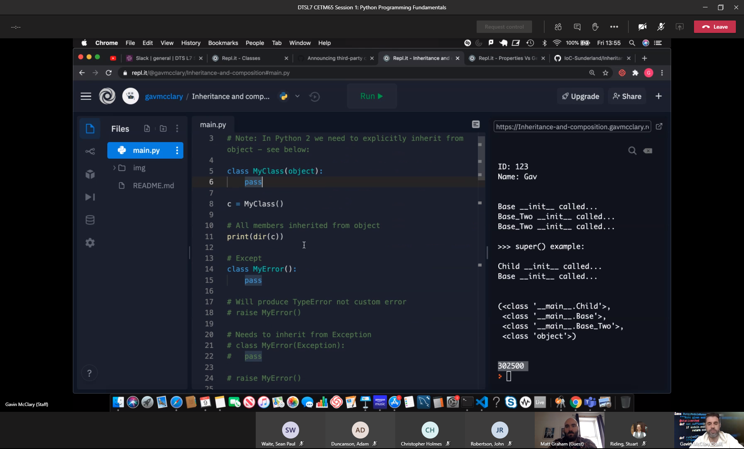

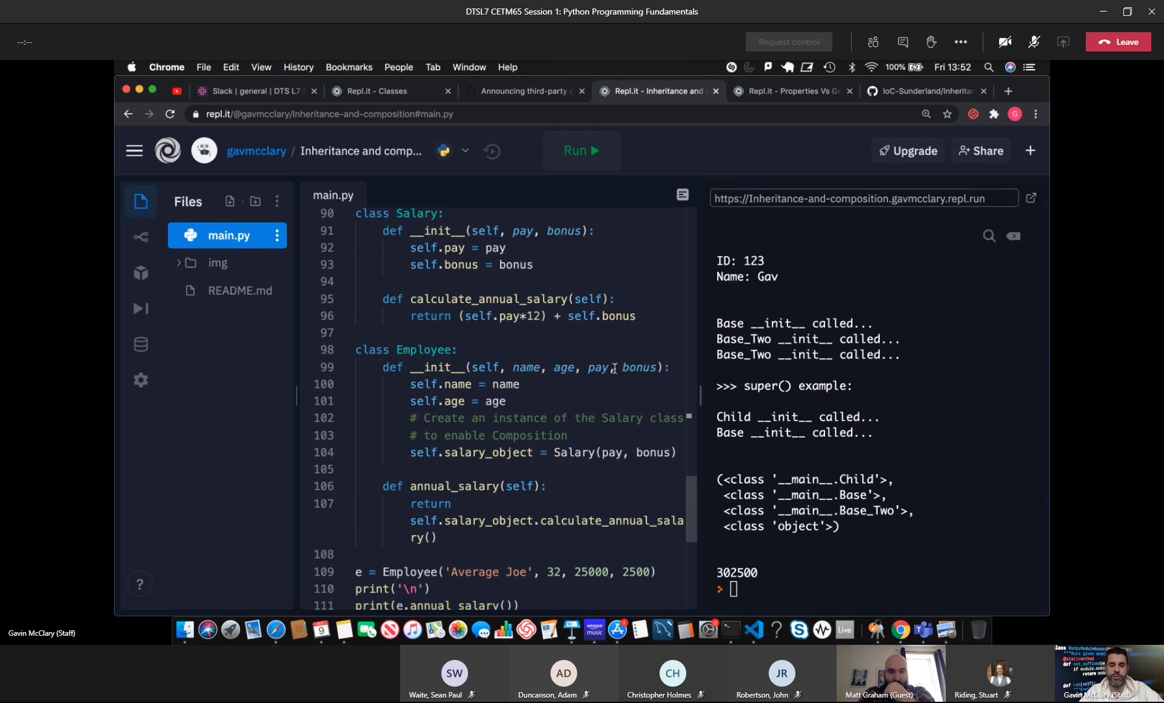

# Abstract base classes

* Decorators

Super()

* The user of super means you don’t have to explicitly create an object, it returns a proxy object

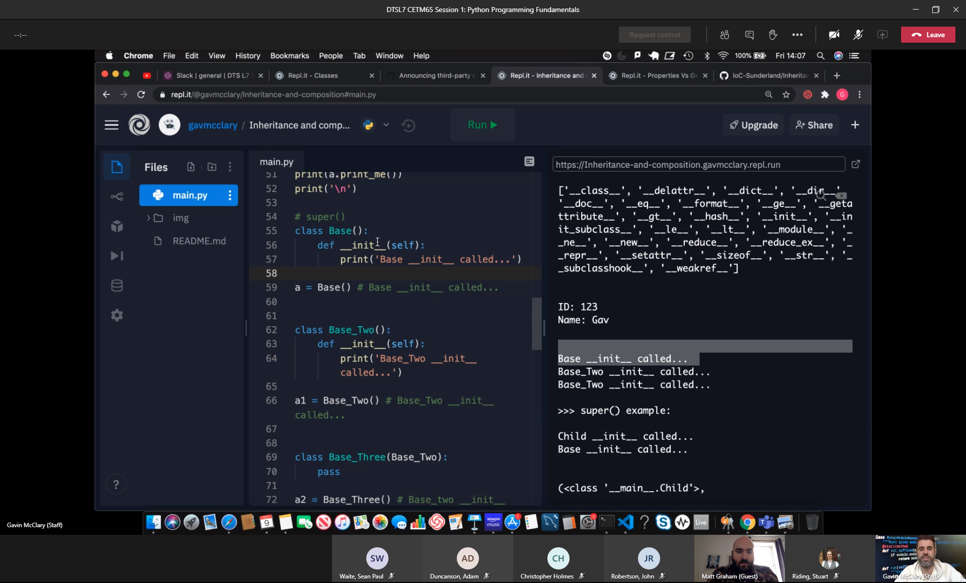

Multiple inheritance

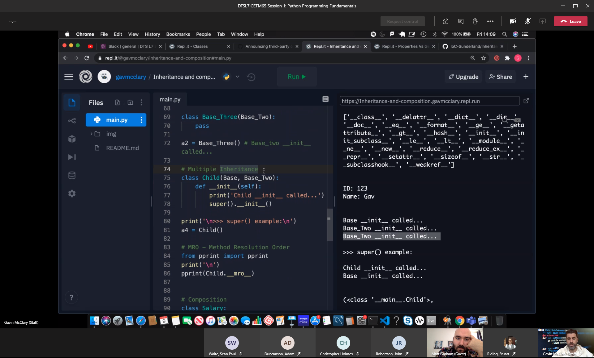

## Public, private and protected instance attributes

Public

* t.baz

Protected

* t._baz

Private

* t.__baz

Python Properties

Print(‘***Standard Class’)

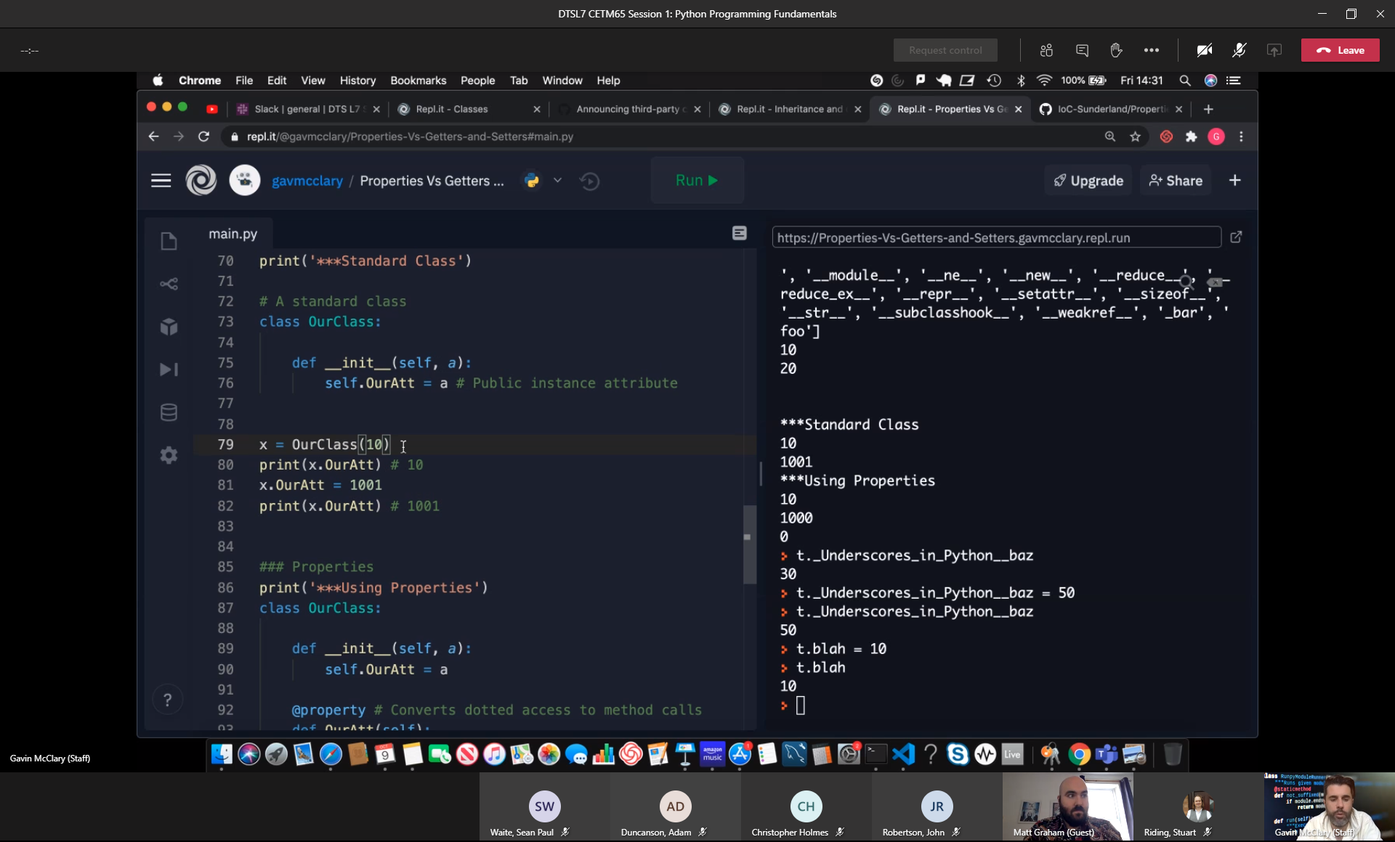

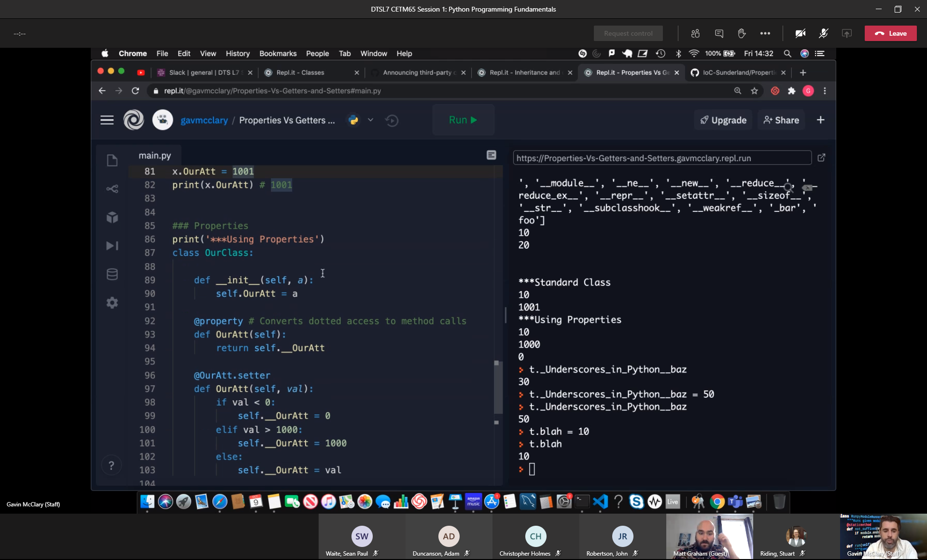

Decorator

@property

Polymorphism